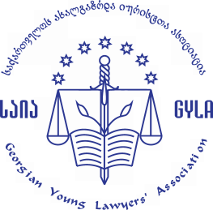


Press Release

High Council of Justice of Georgia Monitoring Report N6 - Presentation
Tbilisi – on June 28, 2018 the Georgian Young Lawyers` Association (GYLA) and Transparency International Georgia presented the sixth monitoring report, which reflects the activity of the High Council of Justice of Georgia of the year 2017; along with other directions, the report assesses legislation that regulates the Council activity and the activity of the Council mentioned while selecting/appointing judges, transparency of the Council activity, a rule and practice while appointing the chairperson of the court and disciplinary liability of judges.
Monitoring revealed the following important consequences:
The Council failed to properly put the ,,Third Wave’’ of the Judicial System Reform into practice – judges were appointed with the same flaws, which the reform mentioned aimed to eradicate. The Council did not implement the positive changes included in the direction of disciplinary liability of judges, among them, an Independent Inspector was appointed with a substantial delay. The problem of all-out unacceptance of pluralism and a critical opinion still remains in the new composition of the Council that prevents subjective discussions and justification of decisions. The accountability system of judges still remains ineffective, which contains a threat to their independence. The vicious practice of appointing acting chairpersons of the court/chamber/panel is maintained. Legislation has such shortcomings, which leave a wide range of possibilities for the Council to take ungrounded and subjective decisions. Namely:
- The composition renewal of the year 2017 was not resulted by the substantial changes in the Council`s activity. The newly elected judge members were considering the continuation of the path taken by the previous composition as the main priority of their activity, while majority of non-judge members could not reveal their individual visions and adequate consistency. The regulation introduced through the ,,Third Wave,, of the Judicial Reform contributed to over concentration of power in the hands of individuals, the regulation mentioned enables the court chairpersons to be a member of the High Council of Justice of Georgia at the same time.

- Persecution of different opinions and demonstration of unhealthy power from the influential group of judges continued. Judge members, typically, stressed the same positions on all the issues and continually managed to gain the support from the required number of non-judge members, to take decisions. During the year 2017, the public eye-witnessed loud conversations at the Council meetings, along with unethical allegations and aggressive statements of personal character, which often had nothing to do with subjective, argumentative reasoning linked to the judicial system.

- Information important to the public is still closed. Among them, particularly problematic are closing the interviewing stage with the demand of unprecedented number of judges (totally 4 in 2014-2016 and 45 in 2017), and also the failure in publicizing the identity and biographic data of participates, who took part in the competition announced on the positions of the Independent Inspector and the Chairperson of the Management Department.

- The ,,Third Wave,, reform is incomplete in the term of selecting/appointing judges, including life-time appointment, which leaves a wide range of arbitrariness for the Council: In the reporting period, over and over, based on groundless and nontransparent decisions, 141 judges were appointed to the positions, among them, 67 for life-time. Justification of the judge candidates assessment, through pointing out the proper sources and evidences is not taken into account and the phase of information retrieval has only formal character; the specific share of interview is not determined in the overall assessment of the candidate; the regulation of appointing the judge through voting makes it possible for the Council members to take decisions without considering estimation results.

- The Council does not attempt staffing the Judiciary Corp with the new members. In the reporting period the High Council of Justice did not announce attendees admission competition; a qualification examination for judges has not been conducted for more than two years, which significantly limits the opportunity to renew the judicial system and recruit it with the judges trusted by the public.

- The Council appoints chairpersons of the court/panel/chamber in absence of relevant standards and procedures, chiefly in an uncompetitive environment. In practice, non-transparent process of candidate nomination still remains problematic, along with groundless appointment of the chairperson and acting chairperson, which might be used to maintain the influence of the Council on individual judges and the judicial system.

- Extremely low index of imposing disciplinary liability on judges, points at ineffectiveness of the accountability mechanism. Simultaneously, the high rate of termination of disciplinary proceedings, in the face of improper transparency, raises doubts regarding objectivity of these decisions.

As a result of the monitoring, relevant recommendations have been provided. We hope that the main findings and recommendations revealed by the monitoring will be taken into account by the members of the Council, executive and legislative bodies. The ,,Georgian Young Lawyers` Association (GYLA)’’ and ,,Transparency International – Georgia’’ will continue to monitor the Council.

Contact persons:

GYLA Transparency International Georgia
Public Relations Manager Public Relations Office
Levan Qatamadze Nino Khurtsidze
Mob. : 577 07 05 00 Mob. : 593 266 177
Email: pr@gyla.ge Email: nino.khutsidze@transparency.ge

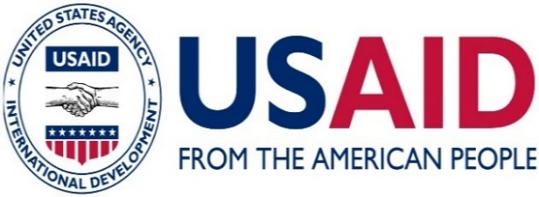
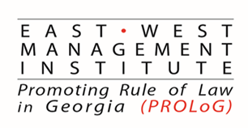

The implementation of the monitoring project was made possible by the generous support of the American people through the United States Agency for International Development (USAID). GYLA and Transparency International Georgia are responsible for the content of the report. It might not necessarily reflect the wives of USAID, the US government or ,,East-West Management Institute (EWMI)’’.

